SIF AU Proposal for Object Plan: |  | 
Time Tabling

Submitted by: | SIF AU Data Standards Working Group
Version: | RC2 V1.0
Date: | 10th November 2009
Status of Object Plan: | Final
○ | Draft | ○ | Final | ○ | Endorsed | ○ | Approved | ○ | Complete
 | awaiting DSWG review |  | awaiting DSWG endorsement |  | awaiting Board approval |  | awaiting publication |  | Published

Time Tabling

Document Version Control
Version | Date | Author/Organization | Comments
V1.0 | 9th November | L Marshall | Accepted changes in document.
Rc2 v03 | 22nd October | LMarshall | Corrected Description of SchoolYear
Rc2 v.02 | 20th October | LMarshall | Changed Root Attributes to elements:  StudentSnapshot:  SchoolYear  RoomInfo  SchoolInfoRefId  TimeTable  SchoolInfoRefId  SchoolYear  TeachingGroup  SchoolYear
rc 2 V0.1 | 11th August | LMarshall | Added changes to TimeTableSubject and TeachingGroup as per WA request for rc2

Referenced Documents
Document | Location
Common Element SIF-AU Specification | SIF community site
Code Set SIF-AU Specification | SIF community site
Common Type SIF-AU Specification | SIF community site
School Info Object Plan and Proposal | SIF community site

Table of Contents

Proposal for Object Plan 5
1. The Business Case for the Collection of TimeTabling Objects 5
2. Time Line 8
3. Business Sponsor/Approvals 8
4. Steps to achieve use case 8
5. Proposed new Data Objects (or changes) 11
6. Glossary of Terms used in Object Definitions 12
Object Plan 13
7. Object Dependencies and Relation Map 13
8. Proposed changes to Existing Objects 14
9. Proposed Changes to SIF Infrastructure 14
Object Definitions 15
10. Object Definition: Base - StudentSnapshot 15
11. Object Definition: Base - StaffPersonal (From School Information) 18
12. Object Definition: Base - StaffAssignment (From School Information) 19
13. Object Definition: Base - RoomInfo (From School Information) 20
14. Object Definition: Base - TimeTableSubject 21
15. Object Definition: Schedule – TimeTable 23
16. Object Definition: Schedule – TeachingGroup 26
17. Object Definition: Schedule – TimeTableCell 28
Extra Issues & Items still being discussed 30
Appendices i
Appendix A - Code Sets for Australian context referred in this Object Plan i
Appendix B – Common Elements for Australian context referred in this Object Plan ii
Appendix C – Common Types for Australian context referred in this Object Plan iii

Proposal for Object Plan

The Business Case for the Collection of Name of Object Objects
Preamble:
Development of this proposal includes assistance from vendors and other participants in the SIF Community. The SIF AU Project team encourages all those with interest and information on improving the specifications to sign up to the interest register (au.sifassociation.org). The SIF-AU plans to provide the mechanisms to allow an open specification to be developed with all those interested to be involved.
Requirement:
According to SIF Specification V2.2, Objects that are associated with TimeTabling refer to daily organisational information and curriculum assessment
“TimeTabling” within an Australian context is more about scheduling, staff, resources, rooms and students to a portion of a day. The SIF Specification V2.2 does not cater for information flow that will allow the actual scheduling of classes or activities. Furthermore, few Schools Student Administration Packages appear to provide TimeTabling functions that meet the proposed style of usage that is relevant to the Australian context.
Many schools use TimeTabling packages where student, staff and room information is exported from the Student Administration System into the third party TimeTabling package. Once the timetable is ‘bedded down’, the information is exported manually from the TimeTabling package and imported back into the Student Administration System.
A sought-after business function to meet expectations of the Australian education community is to respond to a TimeTabling query with accurate information about the whereabouts of a particular student at any particular time of day.
To enable this, sufficient information regarding the scheduling of classes, staff, resources, rooms and students needs to be able to be transferred to and from applications to enable a response from the Schools Administration or Curriculum Delivery System.
SIF Specification (US) V2.2 does not provide a good match to the data that Student Administration Systems need to interface with third party TimeTabling systems. Therefore a need exists to define new object/s to standardise the interaction between packages so that Vendors and Applications have the required interoperability for TimeTabling.
It is expected that improved interoperability between systems will lead to more accurate and consistent exchange of TimeTabling data as well as time savings due to streamlined operations of data transmissions versus the existing method of manual exports and imports.
Interaction between third party TimeTabling packages and Schools Administration Systems is currently available at a School Level but the capability should be provided for development should allow for TimeTabling information from multiple schools

It is expected that interoperability can be achieved via a ZIS or as standardised information flows between third party Time Tabling packages and Schools Student Administration Systems.

CONTEXT DIAGRAM – DATA FLOW BETWEEN RELATED ENTITIES
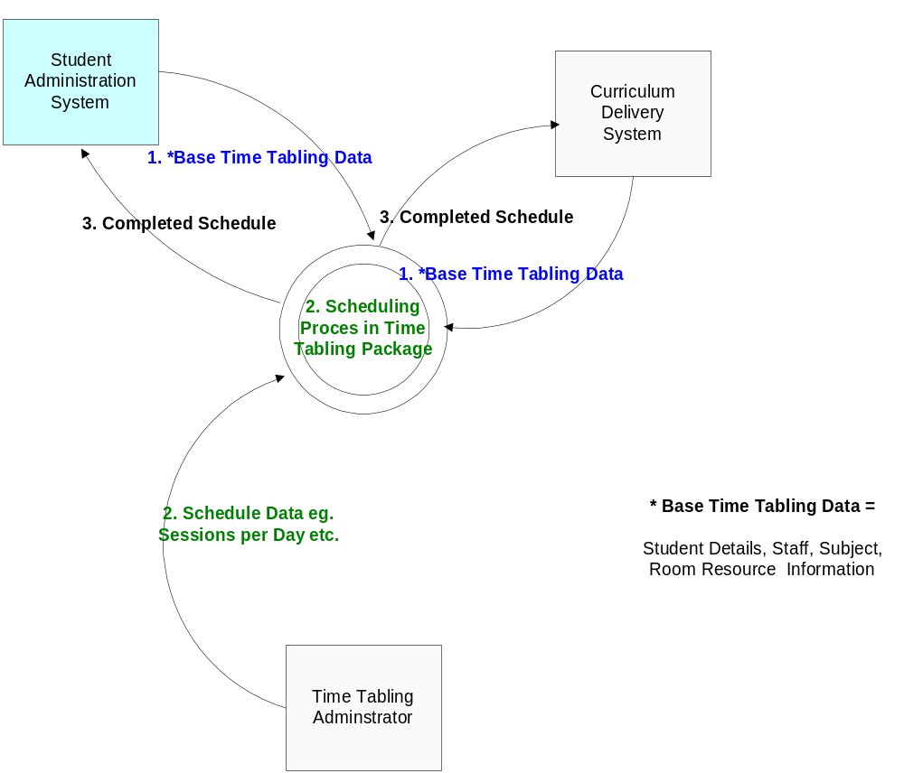

Expected Business Outcomes
End to End Goal | Information will flow between Schools Student Administration Packages, Curriculum Delivery Systems and third Party TimeTabling packages such that subjects, classes, staff, resources, rooms and students can be scheduled and established. TimeTable data can be passed back such that the location of a class, subject, student or teacher can be known within the School’s Student Administration Package or Curriculum Delivery System. (This Business Case is limited to the supply of the ‘Schedule’ so that the Schools Student Administration Package can associate it with the current Calendar.)  The process will involve a number of steps:  - Set up of Base TimeTable information in Student Administration Package, Curriculum Delivery System  - Input Student Data  - Input Room/Resource Data  - Input Subject Data – Curriculum Offerings  - Input Staff Data  - Input Subjects Staff are qualified to teach -optional  - Create export of base TimeTable Information for third Party Package  - Create Schedule in third party TimeTabling Package  - Import Base TimeTable Information  - Additional TimeTabling Data is input by Time Table Administrator Subjects/Curriculum Offerings.  - Scheduling Process Occurs  - School TimeTable Administrator confirms schedule suitability  - Create export Schedule is information  - Schedule Export/Import  - School Administration System or Curriculum Delivery System loads schedule information  - Additional Organisational information updated or confirmed
Input “Choreography” Expectations | (Input to Schools Student Administration Systems – Step 1 & 3)  Base TimeTable Information:  Student, Staff, Room, Subject, Class information held in the Schools Student Administration System or Curriculum Delivery System.  Trigger: School has collected Student Subject Preferences, Teachers have been identified and their subject areas logged, Availability of Rooms has been recorded and proposed Subjects noted. School needs to schedule classes.  •School calendar has been recorded (see above)  •Sessions and session times per day for each day of cycle has been recorded  •Student Subject preferences have been recorded in student management system (optional)  Schedule Export/Import  Schedule information apportioning students, staff, classes and subjects to rooms has been loaded into the Schools Student Administration Systems.  Trigger:  Schedule has been created and is ready to be loaded into receiver systems.
Output “Choreography” Expectations | (Output from Schools Student Administration Systems – Step 2 – Import to Time Tabling Package)  Create Schedule in third party TimeTabling package  Base TimeTable information is loaded into third party package.  Schedule Process occurs, is confirmed and export is Created.  Trigger: Trigger: third party package has scheduled a TimeTable and administration staff have confirmed its validity.
Measure of success | The interactions work seamlessly and efficiently at a school level or to a centralised System.

Time Line
These objects are planned to be released as part of the SIF Specification AU v1.0 due for release in 2009.

Business Sponsor/Approvals
This ObjectPlan is sponsored by the SIF AU Data Standards Working Group in the development of the SIF Specification AU in Australia as part of the “Towards SIF AU Project”.

Steps to achieve use case

Choreography:
Step 1
BASE TIMETABLE INFORMATION

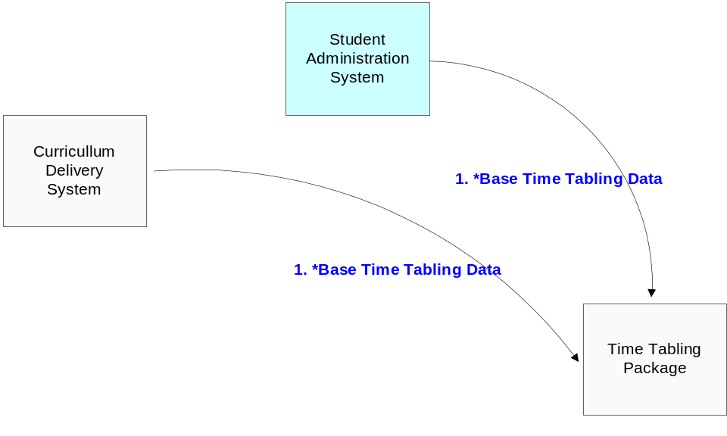

USE CASE – STEP 1 – BASE TIMETABLE INFORMATION

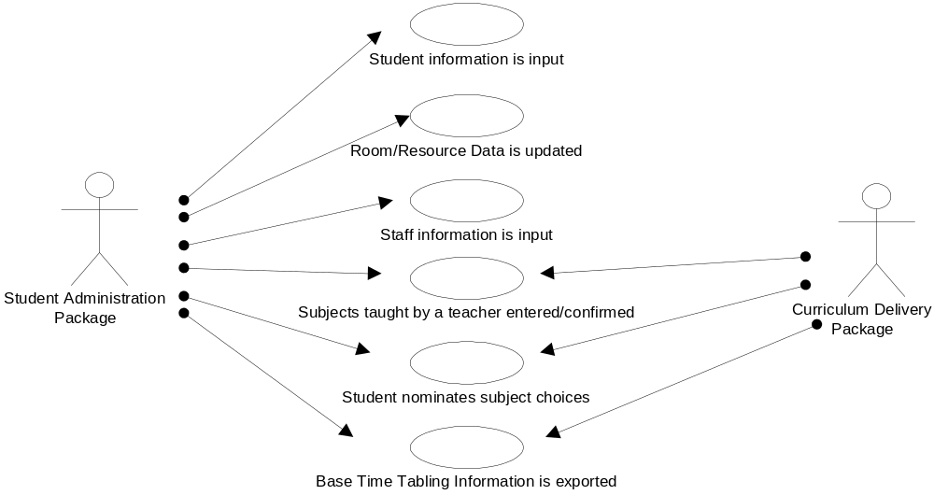

Note: Base Time Table Information related to Students, Staff, Subjects – Curriculum Offerings, Rooms, Subject Choices etc. will be exported from the Primary Source which could be the Student Administration Package or Curriculum Delivery Package. Some Base information may be held in the Time Tabling Package – in which case it will be added in Step 2.

Step 2 – SCHEDULE CREATION

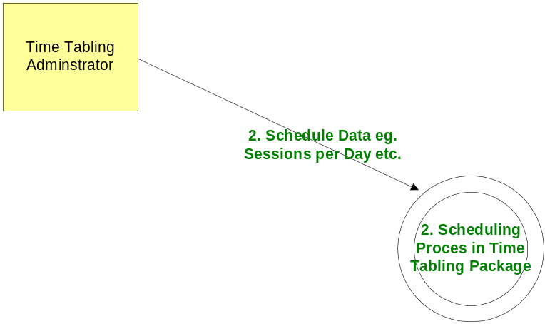

USE CASE – STEP 2 – SCHEDULE CREATION

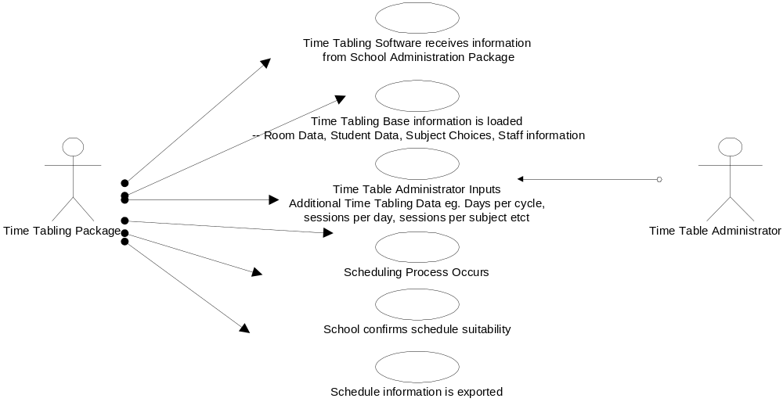

Choreography:
Step 3 - SCHEDULE EXPORT/IMPORT

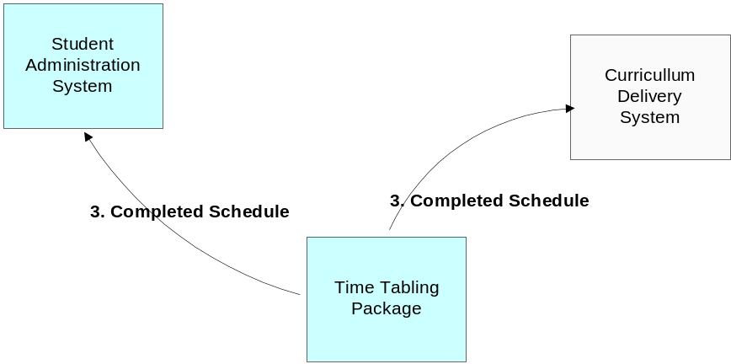

USE CASE – STEP 3 – SCHEDULE EXPORT/IMPORT

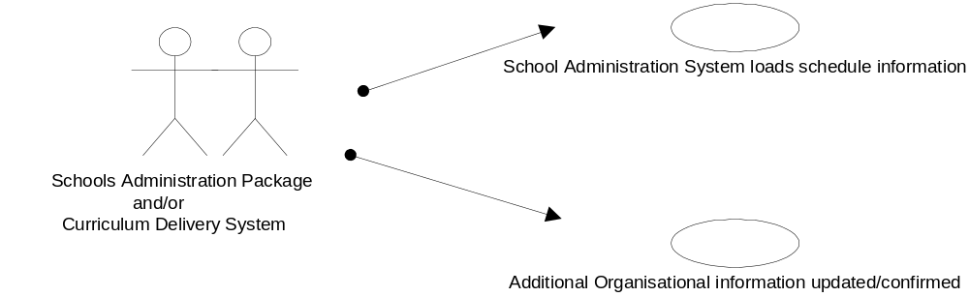

Note:

Any of these events;
Change of Teacher/s &/or subjects eligible to teach
Change of Student/s
Change in Student’s Subject Choice
Change in Room/Resource Data

Will trigger;
An export of Modified Data to the Time Tabling Package eg:

Step 1
 | Creation of Base Time Table Data
  School Administration System | Base Time Table Data Modifed  Changed information is exported | Time Tabling Package

Which will lead to changing in Schedule information as in;
Step 2
Above
And
Step 3
As Above

Proposed new Data Objects (or changes)

The proposed objects to be divided into two groups:
- Base Information:
  - StudentSnapShot OR StudentPersonal and StudentSchoolEnrollment
  - RoomInfo
  - StaffPersonal
  - StaffAssignment
  - TimeTableSubject

- Schedule Information
  - TimeTable
  - Teaching Group
  - TimeTableCell

Glossary of Terms used in Object Definitions
Objects are defined using the following properties:
Property | Definition
Attr | @ indicator to identify the item in the next column is an Attribute of the Object/Element or an Element in its own right.
Name | the name of the attribute or the element
Char | SIF Objects Characteristics, one of:  M = Mandatory  R = Repeatable  O = Optional  C = Conditional  MR = Mandatory Repeatable  OR = Optional Repeatable  CR = Conditional Repeatable
Description | description of the attribute or element
Type | Defined Type (CE) | Common Element defined in SIF US 2.2
 | Defined Type (CE - AU) | Common Element modified/defined for SIF-AU  – See Common Element SIF-AU Document
 | Defined Type (CS) | Code Set defined in SIF US 2.2
 | Defined Type (CS -AU) | Code Set defined modified/defined for SIF-AU  – See Code Set SIF-AU Document
 | Defined Type (CT) | Type and Common Type defined in SIF US 2.2
 | Defined Type (CT-AU) | Type modified/defined for SIF-AU  – See Types SIF-AU Document
 | Defined Type (E–AU) | Element defined in SIF AU Spec
 | xs:<name> | XML Base Type
 | Container | Container Element

Please note: SIF-AU v1.0 will be based on SIF v2.2 where possible.
One area that SIF-AU v1.0 is different is the use of ‘values’ for attributes.
SIF-AU v1.0 will encode all values in Australian Code sets i.e. <name> CS-AU.

Object Plan

Object Dependencies and Relation Map

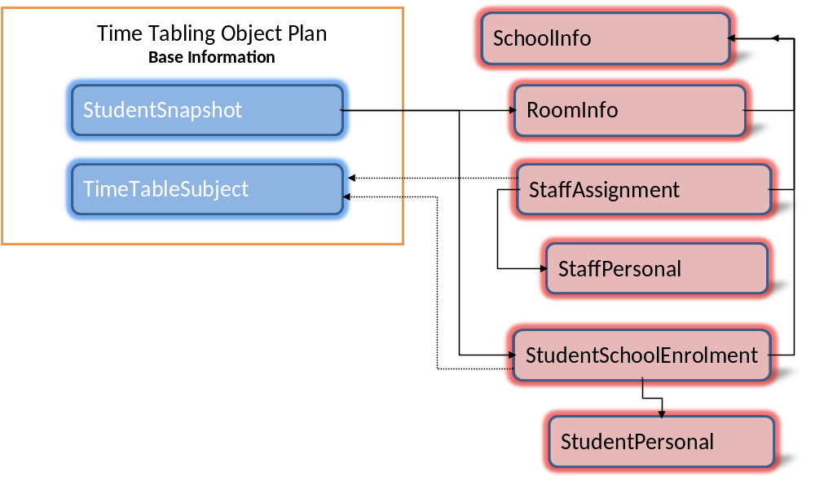

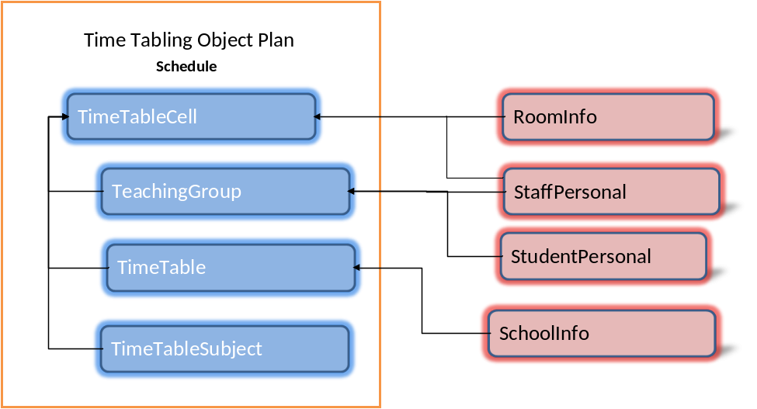

Key to diagrams:
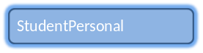 | Blue means this a proposed object for SIF-AU in scope of this. Object Plan
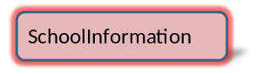 | Pink is an object that is outside the scope of this Object plan, but referred to (required by this Object Plan).

Relation Map

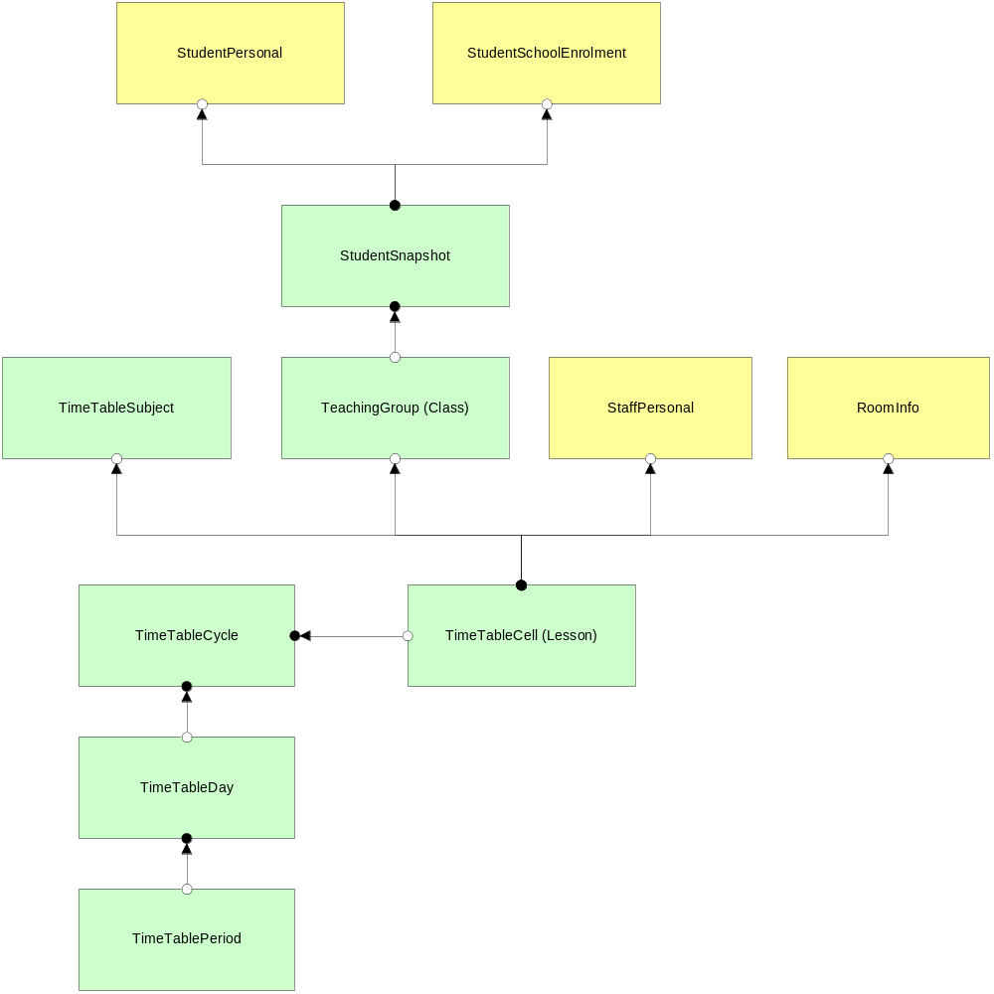

Proposed changes to Existing Objects
N/A – First release.

Proposed Changes to SIF Infrastructure
N/A – Proposing to use current SIF US 2.2 Infrastructure

Object Definitions

Object Definition: Base - StudentSnapshot

10.1 Overview
This object provides a snapshot of a student's record on a given day. The purpose of the StudentSnapshot object is to provide the base student information that is required to populate student information in the TimeTabling application. Please note, The StudentSnapShot object is a subset of information contained in: StudentPersonal, StudentSchoolEnrollment and StudentContact Objects, which should be used instead, if they are currently consumed and maintained by the third-party TimeTabling Package or the Curriculum Delivery System. If the system does not already subscribe to those Student Objects; the StudentSnapShot object provides an alternative object to provide the minimum information.

The StudentSnapShot object is structured to uniquely identify a student at a particular school in a particular year of schooling, at a particular date within the ZIF zone. A StudentSnapShot does not identify a student uniquely i.e. there can be multiple StudentSnapShot objects for 1 student at a particular point in time, each representing an enrolment at a different school. All information reported in the object is reported as it appeared on the date specified in SnapDate.

The object is used for synching data across applications, for periodically loading a data warehouse, or for vertical reporting of data to a requesting authority, such as a state department of education.

For the purpose of initial SIF AU usage – StudentSnapshot will only report on ‘Active’ StudentEnrollment as at the SnapDate.

10.2 Data Object Definition – StudentSnapshot

This object provides a snapshot of a student's record on a given day. All information reported in the object is reported as it appeared in the responding system on the date specified in SnapDate. It can be used for synching data across applications, for periodically loading a data warehouse, or for vertical reporting of data to a requesting authority, such as a state department of education.

SIF Events are not reported for this object.

Attr | Name | Char | Description | Type
@ | SnapDate | M | The date on which this SnapShot is created. | xs:date
@ | StudentPersonalRefId | M | The GUID that identifies the Student | IdRefType (CT)
 | SchoolYear | M | School year for which the information is applicable, expressed as the four-digit year in which the school year ends (e.g., "2009"). | SchoolYear (CE)
 | Name | M | Name of the student | Name (CE-AU)
 | LocalId | M | The locally-defined identifier for this student. | LocalId (CE)
 | StateProvinceId | O | The state-assigned identifier for this student. ( | StateProvinceId (CE)
 | Sex | O | 'Sex' is the distinction 'male' and 'female', as reported by the person. | AU SexCode (CS-AU)
 | BirthDate | O | The person's date of birth. | BirthDate (CE)
 | Age | O | The age (in years) of the student on the date in SnapDate. | xs:unsignedInt
 | ProjectedGraduationYear | O | Currently projected graduation year. | ProjectedGraduationYear (CE)
 | OnTimeGraduationYear | O | First projected graduation year, usually determined when student is accepted into YearNine. | OnTimeGraduationYear (CE)
 | StudentSubjectChoiceList | O | List of Student Subject Choices where available. | StudentSubject ChoiceList (CE-AU)
 | HomeEnrollment | M | Enrollment-related information for the school that is responsible for reporting the student's membership. This is most likely the primary enrollment site for the student. | Container
 | HomeEnrollment/StudentSchoolEnrollmentRefId | O | The ID (GUID) of the StudentSchoolEnrollment object from which the enrollment information is derived. | IdRefType (CT)
 | HomeEnrollment/SchoolName | O | Name of the school. | xs:normalizedString
 | HomeEnrollment/SchoolInfoRefId | C | The ID (GUID) of the school. Provide both the HomeEnrollment/SchoolInfo RefId and HomeEnrollment/LocalId elements if possible. If not, one or the other must be provided. | IdRefType (CT)
 | HomeEnrollment/LocalId | C | The locally-defined identifier for this school. Provide both the HomeEnrollment/LocalId and HomeEnrollment/SchoolId elements if possible. If not, one or the other must be provided. | LocalId (CT)
 | HomeEnrollment/SchoolNo | O | The state or province defined identifier for this school. | LocalId (CT)
 | HomeEnrollment/YearLevel | O | Grade or academic level of student. | YearLevel (CE-AU)
 | HomeEnrollment/Homeroom | O | HomeGroup this student belongs to | IdRefType (CT)
@ | SIF_RefObject | O | The name of the sif object referenced | RoomInfo
 | HomeEnrollment/HomeroomNumber | O | The locally-defined identifier of that room | HomeRoomNumber (CE)
 | SIF_Metadata | O |  | SIF_Metadata
 | SIF_ExtendedElements | O |  | SIF_ExtendedElements

Assumptions around the use of this object:
- The StudentPersonal Object must have been previously published by the provider in the zone.
- The consuming agent may not have previously received the StudentPersonal Object but must use the contents of the ‘StudentPersonalRefId’ in the return of its schedule information so that the Schedule & Student information can be matched correctly.

10.3 Element: StudentSubjectChoiceList
This elements contains information, that when known in the Schools Student Administration package, can be exported as part of the Student Snapshot OR StudentInformation object. In some cases this information is programmed into the schedule generation application. Therefore this is an optional element and is included in the StudentSnapshot Object and StudentInformation as a List of Optional Repeatable Student Subject Choices. This element is a common element and will be managed through the Common Elements Document.

10.4 Sample XML - StudentSnapshot
<StudentSnapshot SnapDate="2003-10-01" StudentPersonalRefId="A15484ED564995254A4568EFFC5100BD" SchoolYear="2008">
<Name Type=LGL>
<FamilyName>Johnson</FamilyName>
<GivenName>Alison</GivenName>
<PreferredName>Al</PreferredName>
</Name>
<LocalId>JOH0001</LocalId>
<StateProvinceId>9987654321</StateProvinceId>
<Sex>F</Sex>
<BirthDate>1992-03-02</BirthDate>
<Age>17</Age>
<ProjectedGraduationYear>2010</ProjectedGraduationYear>
<OnTimeGraduationYear>2010</OnTimeGraduationYear>
<StudentSubjectChoicesList>
<StudentSubjectChoice>
<PreferenceNumber>1</PreferenceNumber>
<SubjectLocalId>English</SubjectLocalId>
</StudentSubjectChoice>
<StudentSubjectChoice>
<PreferenceNumber>2</PreferenceNumber>
<SubjectLocalId>Science</SubjectLocalId>
</StudentSubjectChoice>
<StudentSubjectChoice>
<PreferenceNumber>3</PreferenceNumber>
<SubjectLocalId>Geography</SubjectLocalId>
</StudentSubjectChoice>
<StudentSubjectChoice>
<PreferenceNumber>4</PreferenceNumber>
<SubjectLocalId>Legal Studies</SubjectLocalId>
</StudentSubjectChoice>
</StudentSubjectChoicesList>
<HomeEnrollment>
<StudentSchoolEnrollmentRefId> 0847987235489729AAA73011BB365EC3
</StudentSchoolEnrollmentRefId>
<SchoolName>Waverley Secondary College</SchoolName>
<SchoolInfoRefId>834787627836AC74B05EE3066ABC9231</SchoolInfoRefId>
<LocalId>01012345</LocalId>
<SchoolNo>01012345</SchoolNo>
<EnrolStatus>ACTV</EnrolStatus>
<YearLevel>
<Code>9</Code>
</YearLevel>
<Homeroom SIF_RefObject="RoomInfo">9475683579BA648E0548DDA8365700F4
</Homeroom>
<HomeroomNumber>B024</HomeroomNumber>
</HomeEnrollment>
</StudentSnapshot>

Object Definition: Base - StaffPersonal (From School Information)
11.1 Overview
Base Staff information is required to allow Staff to be scheduled. The relevant objects are StaffPersonal and Staff Assignment and they are defined in the School Information Object Plan.

11.2 Example XML - StaffPersonal
<StaffPersonal RefId="D3E34F419D75101A8C3D00AA001A1652">
<LocalId>946379881</LocalId>
<StateProvinceId>C2345681</StateProvinceId>
<ElectronicIdList>
<ElectronicId Type="Barcode">206655</ElectronicId>
</ElectronicIdList>
<OtherIdList>
<OtherId Type="FreeTextType">333333333</OtherId>
</OtherIdList>
<Name Type="LGL">
<Prefix>Mr.</Prefix>
<FamilyName>Woodall</FamilyName>
<GivenName>Charles</GivenName>
<MiddleName>William</MiddleName>
<PreferredName>Chuck</PreferredName>
</Name>
<Demographics> ---*** Note see StudentPersonal for an full example of demographics
<Sex>1</Sex>
</Demographics>
<Title>Principal</Title>
<AddressList>
<Address Type=012B>
<Street>
<Line1>1/33 St. Kilda Road</Line1>
</Street>
<City>Melbourne</City>
<StateProvince>VIC</StateProvince>
<Country>1101</Country>
<PostalCode>3000</PostalCode>
</Address>
</AddressList>
<PhoneNumberList>
<PhoneNumber Type= 0096
<Number>(03) 9876-1234</Number>
<Extension>2345</Extension>
</PhoneNumber>
</PhoneNumberList>
<EmailList>
<Email Type="Primary">chuckw@imginc.com.au</Email>
</EmailList>
</StaffPersonal>

11.3 For discussion:
No remaining items for discussion.

Object Definition: Base - StaffAssignment (From School Information)
12.1 Overview
Base Staff information is required to allow Staff to be scheduled. The relevant objects are StaffPersonal and Staff Assignment and they are defined in the School Information Object Plan.

12.2 Example XML – StaffAssignment
<StaffAssignment RefId="D3E34B359D75101A8C3D00AA001A1652" SchoolInfoRefId="A8C3D3E34B359D75101D00AA001A1652" SchoolYear="2008" StaffPersonalRefId="D3E34B359D75101A8C3D00AA001A1651">
<Description>VCE English Teacher</Description>
<PrimaryAssignment>Yes</PrimaryAssignment>
<JobStartDate>2000-09-05</JobStartDate>
<JobEndDate>2001-06-25</JobEndDate>
<JobFTE>1.00</JobFTE>
<JobFunction>Teacher<JobFunction>
</JobFunction>
<StaffSubjectList>
<StaffSubject>
<PreferenceNumber>1</PreferenceNumber>
<SubjectLocalId>07EN</SubjectLocalId>
</StaffSubject)
<StaffSubject>
<PreferenceNumber>2</PreferenceNumber>
<SubjectLocalId>07MA</SubjectLocalId>
</StaffSubject)
<StaffSubject>
<PreferenceNumber>3</PreferenceNumber>
<SubjectLocalId>07AR</SubjectLocalId>
</StaffSubject)
<StaffSubjectList>
<YearLevels>
<YearLevel
<Code>11</Code>
</YearLevel>
<YearLevel>
<Code>12</Code>
</YearLevel>
</YearLevels>
<CasualReliefTeacher>No</CasualReliefTeacher>
<EmployeePersonalRefId>43E34B359D75101A8C3D00AA001A1652</EmployeePersonalRefId>
</StaffAssignment>

12.3 For discussion:
No further issues for discussion.

Object Definition: Base - RoomInfo (From School Information)
13.1 Overview
Base Room information is required to allow it to be scheduled as a resource. This information is described below as XML, RoomInfo is defined fully in the School Information Object Plan SIF AU Specification. For timetabling, this object must identify the minimum characteristics of a room that will allow it to be scheduled as a resource – see the sample XML below.

  - Data Object Definition- RoomInfo
See RoomInfo in SchoolInformation Proposal for Object Plan

Attr | Name | Char | Description | Type
@ | RefId | M | GUID that identifies this room. | RefIdType (CT)
 | SchoolInfoRefId | M | GUID that identifies the school that this room belongs to. | IdRefType (CT)
 | RoomNumber | M | Room number as presented to the user/application. | xs:normalizedString
 | StaffList | O | Container element for staff assigned to this room | Container
 | StaffList/StaffPersonalRefId | MR | GUID that identifies the staff person assigned to this room (e.g. the homeroom teacher). | IdRefType (CT)
 | Description | O | Friendly name that can be assigned to the room (e.g. Staff Cafeteria). | xs:normalizedString
 | Building | O | Extra building information. In the future Building could become its own object in which case this element will need to be changed to a RefId. Currently it is only required as a free text field. | xs:normalizedString
 | HomeroomNumber | O | When a room is designated as a homeroom it may have a different number. Usually blank when room is not a homeroom. | xs:normalizedString
 | Size | O | Size in square metres | xs:decimal
 | Capacity | O | Number of persons (usually students) that this room can hold. | xs:unsignedInt
 | PhoneNumber | O | Phone number for the room | PhoneNumber (CE_AU)
 | SIF_Metadata | O |  | SIF_Metadata
 | SIF_ExtendedElements | O |  | SIF_ExtendedElements

13.3 Example XML - RoomInfo
<RoomInfo RefId="D3E34B359D75101A8C3D00AA001A1652" SchoolInfoRefId="A2E35B359D75101A8C3D00AA001A0000">
<RoomNumber>101</RoomNumber>
<Description>Room 101</Description>
<Capacity>35</Capacity>
</RoomInfo>

13.4 For discussion:
No remaining items for discussion.

Object Definition: Base - TimeTableSubject
14.1 Overview
This purpose of this object is to define and communicate the subject or distinct piece of curriculum that needs to be scheduled by the time table generator. This is a new object proposed to meet SIF-AU needs. Reviews of the existing specifications identified two relevant objects – SchoolCourseInfo, defined in SIF US 2.2 specification and SchoolGroup, defined within the SIF UK 1.1 specification. These objects appear to have some similar context but seem overly complex considering that Australian requirements, which are limited to the Student Administration System or Curriculum Delivery System providing base information to the Time Tabling application about what curriculum offerings are being proposed.

When this data is sent in a Request/Response only those subjects that are relevant to be scheduled (or active), should be sent to the TimeTabling application.

  - Data Object Definition – TimeTableSubject

SIF Events are reported for this object.
Attr | Name | Char | Description | Type
@ | RefId | M | GUID that identifies this TimeTableSubject. | RefIdType (CT)
 | SubjectLocalId | M | SubjectLocalID - Distinct piece of curriculum that is to be scheduled. | LocalId (CE)
 | AcademicYear | C | Subject Year Level. Either AcademicYear or AcademicYearRange must be provided. | YearLevel (CS-AU)
 | AcademicYearRange | C | Range of Academic Years subject spans. Either AcademicYear or AcademicYearRange must be provided. | Container
 | AcademicYearRange/Start | M | Lowest year in range. | YearLevel (CS-AU)
 | AcademicYearRange/End | M | Highest year in range | YearLevel (CS-AU)
 | CourseLocalId | O | Local Course Id, if associated with a Course. | LocalId (CE)
 | SchoolCourseInfoRefId | O | The GUID of the SchoolCourseInfo object. | RefIdType (CT)
 | Faculty | O | Faculty | xs:normalizedString
 | SubjectShortName | O | SubjectShortName | xs:normalizedString
 | SubjectLongName | M | SubjectLongName | xs:normalizedString
 | SubjectType | O | Core or Elective or ? | xs:normalizedString
 | ProposedMaxClassSize | O | Suggested maximum class size for this subject. | xs:decimal
 | ProposedMinClassSize | O | Suggested minimum class size for this subject. | xs:decimal
 | SchoolInfoRefId | O | Optional the GUID of the SchoolInfo Object if this object is known in the zone | IdRefType (CT)
 | SchoolLocalId | O | Optional Local School Id | LocalId (CE)
 | Semester | O | Semester/Term/Quarter subject offered. | xs:unsignedInt
 | SchoolYear | O | School year for which the information is applicable, expressed as the four-digit year in which the school year ends (e.g., "2009”). | SchoolYear (CE)
 | OtherCodeList | O | Any other codes this subject is know by; eg VASS code for VCE in Vic | OtherCodeList (CE)
 | SIF_Metadata | O |  | SIF_Metadata
 | SIF_ExtendedElements | O |  | SIF_ExtendedElements

14.4 Example XML - TimeTableSubject

<TimeTableSubject RefId="12235400000007AR">
<SubjectLocalId>07AR</SubjectLocalId>
<AcademicYear>7</AcademicYear>
<ShortName>7 ART</ShortName>
<SubjectLongName>Year 7 Art</SubjectLongName>
<SubjectType>E</SubjectType>
<SchoolYear>2009</SchoolYear>
</TimeTableSubject>

14.5 For discussion:
No remaining items for discussion.

Object Definition: Schedule – TimeTable
15.1 Overview
The purpose of this object is to define a schedule or Time Table structure/skeleton for the school. The Time Table is produced by the Time Tabling software. Once the Time Table is produced, the time tabling software creates the schedule based on business rules and constraints to fit into the time table structure..

The proposed Time Table object is based on a combination of the proposed UK B6 – Timetable Cycle Object and Timetable Scope Object.

The Time Table is identified uniquely in the SIF Zone by it’s GUID, School and School Year. A Time Table is linked to a particular school.

  - Data Object Definition – TimeTable

SIF Events are reported for this object.

Attr | Name |  | Char |  | Description |  | Type
@ |  | RefId |  | M |  | GUID that identifies this TimeTable object. |  | RefIdType (CT)
 |  | SchoolInfoRefId |  | O |  | Optional the GUID of the SchoolInfo Object if this object is known in the zone. |  | IdRefType (CT)
 |  | SchoolYear |  | M |  | School year for which the information is applicable, expressed as the four-digit year in which the school year ends (e.g., "2009”). |  | SchoolYear (CT)
 |  | LocalId |  | O |  | Local TimeTable ID |  | LocalId (CE)
 |  | Title |  | M |  | Unique Name of the proposed Time Table |  | xs:normalizedString
 |  | DaysPerCycle |  | M |  | Max Number of days per Time Table cycle |  | xs:unsignedInt
 |  | PeriodsPerDay |  | M |  | Max Number of periods per Time Table Day |  | xs:unsignedInt
 |  | TeachingPeriodsPerDay |  | O |  | Teaching periods per day if different to PeriodsPerDay |  | xs:unsignedInt
 |  | SchoolLocalId |  | O |  | Optional Local School Id |  | LocalId (CT)
 |  | SchoolName |  | O |  | The school name in plain text. |  | xs:normalizedString
 |  | TimeTableCreationDate |  | O |  | Date Schedule was created or last edited. |  | xs:date
 |  | StartDate |  | O |  | First day of TimeTable. |  | xs:date
 |  | EndDate |  | O |  | Last day of the TimeTable. |  | xs:date
 |  | TimeTableDayList |  | M |  | Container for TimeTableDays in Schedule |  | TimeTableDayList (E- AU)
 |  | SIF_Metadata |  | O
 |  | SIF_ExtendedElements |  | O

  - Element: TimeTableDayList
This element contains a list of TimeTableDay elements

Attr | Name | Char | Description | Type
 | TimeTableDayList |  | List of TimeTableDays | List
 | TimeTableDay | MR | This element identifies a ‘day’ in a TimeTable. | TimeTableDay  (E-AU)

  - Element: TimeTableDay
This element identifies a ‘day’ in a TimeTable.
Attr | Name | Char | Description | Type
 | DayId | M | Local Time Table Identifier | LocalId (CT)
 | DayTitle | M | Title of Day eg. Monday or Day 1 | xs:normalizedString
 | TimeTablePeriodList | M | Container for TimeTablePeriods in a Time Table Day | TimeTablePeriodList (E-AU)

  - Element: TimeTablePeriodList
This element defines a ‘container element for TimeTable Periods

Attr | Name | Char | Description | Type
 | TimeTablePeriodList |  | List of TimeTablePeriods | List
 | TimeTablePeriod | MR | This element identifies a period/or a session within a TimeTable Day. | TimeTablePeriod (E-AU)

  - Element: TimeTablePeriod
This element defines a period/or a session within a TimeTable Day

Attr | Name | Char | Description | Type
 | PeriodId | M | Period in Day Identifier | LocalId (CT)
 | PeriodTitle | M | Title of Period eg. Session 1 or Period 1 | xs:normalizedString

  - Sample XML
<TimeTable RefId="64A309DA063A2E35B359D75101A8C3D0" SchoolInfoRefId="019991" SchoolYear = 2008>
<LocalId>2008S1</LocalId>
<Title>2008 Semester 1</Title>
<DaysPerCycle>5</DaysPerCycle>
<PeriodsPerDay>6</PeriodsPerDay>
<TeachingPeriodsPerDay>5</TeachingPeriodsPerDay>
<SchoolLocalId>01011234</SchoolLocalId>
<SchoolName>Newest Secondary College</SchoolName>
<TimeTableCreationDate>2008-02-01</TimeTableCreationDate>
<StartDate>2008-01-30</StartDate>
<EndDate>2008-06-20</EndDate>
<TimeTableDayList>
<TimeTableDay>
<DayId>1</DayId>
<DayTitle>Monday</DayTitle>
<TimeTablePeriodList>
<TimeTablePeriod>
<PeriodId>1</PeriodId>
<PeriodTitle>P1</PeriodTitle>
</TimeTablePeriod>
<TimeTablePeriod>
<PeriodId>2</PeriodId>
<PeriodTitle>P2</PeriodTitle>
</TimeTablePeriod>
<TimeTablePeriod>
<PeriodId>3</PeriodId>
<PeriodTitle>P3</PeriodTitle>
</TimeTablePeriod>
<TimeTablePeriod>
<PeriodId>4</PeriodId>
<PeriodTitle>P4</PeriodTitle>
</TimeTablePeriod>
<TimeTablePeriod>
<PeriodId>5</PeriodId>
<PeriodTitle>P5</PeriodTitle>
</TimeTablePeriod>
<TimeTablePeriod>
<PeriodId>6</PeriodId>
<PeriodTitle>P6</PeriodTitle>
</TimeTablePeriod>
</TimeTablePeriodList>
</TimeTableDay>
<TimeTableDay>
<DayId>2</DayId>
<DayTitle>Tuesday</DayTitle>
<TimeTablePeriodList>
<TimeTablePeriod>
<PeriodId>1</PeriodId>
<PeriodTitle>P1</PeriodTitle>
</TimeTablePeriod>
<TimeTablePeriod>
<PeriodId>2</PeriodId>
<PeriodTitle>P2</PeriodTitle>
</TimeTablePeriod>
<TimeTablePeriod>
<PeriodId>3</PeriodId>
<PeriodTitle>P3</PeriodTitle>
</TimeTablePeriod>
<TimeTablePeriod>
<PeriodId>4</PeriodId>
<PeriodTitle>P4</PeriodTitle>
</TimeTablePeriod>
<TimeTablePeriod>
<PeriodId>5</PeriodId>
<PeriodTitle>P5</PeriodTitle>
</TimeTablePeriod>
<TimeTablePeriod>
<PeriodId>6</PeriodId>
<PeriodTitle>P6</PeriodTitle>
</TimeTablePeriod>
</TimeTablePeriodList>
</TimeTableDay>
---****.(Repeat for the number of Days in the Cycle)
</TimeTableDayList>
</TimeTable>

14.8 For discussion:
No remaining items for discussion.

Object Definition: Schedule – TeachingGroup
16.1 Overview
This object identifies a particular Teaching Group or class in a particular a Time Table.

For example, there may be 3 groups or classes of students of Year 7 Maths. Each group gets scheduled 5 times in the time table schedule. Each of these groups is defined as a ‘Teaching Group’ – a group of students brought together for the teaching of a specific subject.

The proposed object is based on the UK B1: Teaching Group object. For the Australian object, a subject being taught at any one year level can have more than one ‘teaching group’ in any one time table. Also a teaching group can be brought together for more than one subject.

  - Data Object Definition

SIF Events are reported for this object.

Attr | Name | Char | Description | Type
@ | RefId | M | The GUID of the TeachingGroup | RefIdType (CT)
 | SchoolYear | O | School year for which the information is applicable, expressed as the four-digit year in which the school year ends (e.g., "2009"). | SchoolYear (CT)
 | LocalId | M | LocalId of the Teaching Group (previously ClassIndicator). | LocalId (CT)
 | ShortName | M | Short free format label that describes the group. | xs:normalizedString
 | LongName | O | Longer description of required | xs:normalizedString
 | Set | O | Set Number (UK) | xs:normalizedString
 | Block | O | Block (UK) | xs:normalizedString
 | CurriculumLevel | O | Assessment Stage eg VELS Level | xs:normalizedString
 | SchoolInfoRefId | O | GUID of SchoolInfo object this teaching group belongs to. | RefIdType (CT)
 | SchoolLocalId | O | Local School Id. | LocalId (CT)
 | SchoolCourseInfoRefId | O | GUID of SchoolCourseInfo object this teaching group is part of. | RefIdType (CT)
 | SchoolCourseLocalId | O | Local Course Id. | LocalId (CT)
 | TimeTableSubjectRefId | O | GUID of TimeTableSubject object this teaching group belongs to. | RefIdType (CT)
 | TimeTableSubjectLocalId | O | Local subject id. | LocalId (CT)
 | StudentList | O | List of Students in this Teaching Group | StudentList(E-AU)
 | TeacherList | O | A List of teachers associated with the group – may or maynot include the teacher timetabled in the schedule. | TeacherList (E-AU)
 | MinClassSize | O | MinimumClass Size | xs:integer
 | MaxClassSize | O | MaximumClassSize | xs:integer
 | SIF_Metadata | O
 | SIF_ExtendedElements | O
  - Element: StudentList
Attr | Name | Char | Description | Type
 | StudentList |  | List of TeachingGroupStudents | List
 | TeachingGroupStudent | MR | Students who belong to the TeachingGroup | TeachingGroup Student (CE-AU)

  - Element: TeachingGroupStudent
Attr | Name | Char | Description | Type
 | StudentPersonalRefId | O | GUID from the StudentPersonal or StudentSnapshot Object (if known), that identifies the student. | IdRefType (CT)
 | StudentLocalId | M | Local Id of the Student | LocalId(CE)
 | Name | M | Name of student | NameofRecordType (CT-AU)

  - Element: TeacherList
Attr | Name | Char | Description | Type
 | TeacherList |  | List of TeachingGroup Teachers | List
 | TeachingGroupTeacher | MR | Teacher associated with the Teaching group – may or may not be the teacher timetabled in the schedule | TeachingGroup Teacher (E-AU)

16.5 Element: TeachingGroupTeacher
Attr | Name | Char | Description | Type
 | StaffPersonalRefId | O | GUID from the StaffPersonal Object that identifies the Staff member | IdRefType (CT)
 | StaffLocalId | M | LocalId of the Staff member | LocalId (CE)
 | Name | M |  | NameofRecordType (CT-AU)
 | Association | M | Association with the Teaching Group (free format for this release) | xs:normalizedString

16.6 Sample XML

<TeachingGroup RefId="64A309DA063A2E35B359D75101A8C3D1>"
<LocalId>20087ASPN</LocalId>
<Shortname>7A SPN</Shortname>
<Longname>Year 7A Maths – Space and Numbers</Longname>
<Set>4</Set>
<Block>6</Block>
<Curriculum Level>VELS Level 5</Curriculum Level>
<StudentList>
<TeachingGroupStudent>
<StudentPersonalRefId>7C834EA9eDA12090347F83297E1C290C
</StudentPersonalRefId>
<StudentLocalId>SMI001</StudentLocalId>
<Name Type=”LGL”
<FamilyName>Smith</FamilyName>
<GivenName>Peter<GivenName>
<PreferredName>Pete</PreferredName>
</Name>
</TeachingGroupStudent>
<TeachingGroupStudent>
<StudentPersonalRefId>7C834EA9eDA12090347F83297E1C290D”
</StudentPersonalRefId>
<StudentLocalId>SMI002</StudentLocalId>
<Name Type=”LGL”
<FamilyName>Smith</FamilyName>
<GivenName>Jennifer<GivenName>
<PreferredName>Jenny</PreferredName>
</Name>
</TeachingGroupStudent>
<TeachingGroupStudent>
<StudentPersonalRefId>7C834EA9eDA12090347F83297E1C290E
</StudentPersonalRefId>
<StudentLocalId>SMI003</StudentLocalId>
<Name Type=”LGL”
<FamilyName>Smith</FamilyName>
<GivenName>Terence<GivenName>
<PreferredName>Terry</PreferredName>
</Name>
</TeachingGroupStudent>
</StudentList>
<TeacherList>
<TeachingGroupTeacher>
<StaffPersonalRefId>A8C3A2E35B359D75101D00AA001A0000
</StaffPersonalRefId>
<StaffLocalId>SMI1</StudentLocalId>
<Name Type=”LGL”
<FamilyName>Smith</FamilyName>
<GivenName>Thomas<GivenName>
</Name>
<Association>Class Teacher</Association>
</TeachingGroupTeacher>
<TeachingGroupTeacher>
<StaffPersonalRefId>A8CCCCE35B359D75101D00AA001A0000
</StaffPersonalRefId>
<TeacherLocalId>LONG2</TeacherLocalId>
<Name Type=”LGL”
<FamilyName>Long</FamilyName>
<GivenName>Tamara<GivenName>
<PreferredName>Tammy</PreferredName>
</Name>
<Association>Integration Aide</Association>
</TeachingGroupTeacher>
</TeacherList>
</TeachingGroup>

16.7 Issues for discussion
None remaining

Object Definition: Schedule – TimeTableCell
17.1 Overview
The purpose of this object is to identify a specific cell within a particular TimeTable. A Time table is a structure that represents all the available days and times (periods) for which a particular teach group, or subject can be scheduled.

A TimeTableCell is uniquely identified in the ZIF zone byits GUID,

- And the following must be provided at object creation:
- the timetable it belongs to,
- the subject that is being scheduled,
- the teaching group (representing the students, teachers and subject)
- the room that is allocated
- the allocated teacher

17.2 Data Object Definition

SIF Events are reported for this object.

Attr | Name | Char | Description | Type
@ | RefId | M | The GUID of the TimeTableCell | RefIdType (CT)
 | TimeTableRefId | M | The GUID of the TimeTable to which this Cell belongs | IdRefType (CT)
 | TimeTableSubjectRefId | M | The GUID of the Subject that this Cell is scheduling | IdRefType (CT)
 | TeachingGroup | M | The GUID of the TeachingGroup being scheduled | IdRefType (CT)
 | RoomInfoRefId | M | The GUID of the Resource being Scheduled | IdRefType (CT)
 | StaffPersonalRefId | M | The GUID of the Staff Member being Scheduled | IdRefType (CT)
 | TimeTableLocalId | O | Time Table Local Identifier | LocalId (CE)
 | SubjectLocalId | O | Subject Local Id | LocalId (CE)
 | TeachingGroupLocalId | O | Teaching Group | LocalId (CE)
 | RoomNumber | M | Room number as presented to the user/application. | xs:token
 | StaffLocalId | O | Staff LocalId | LocalId (CE)
 | DayId | M | Day Id | LocalId (CE)
 | PeriodId | M | Period Id within the Day Id | LocalId (CE)
 | CellType | M | Type of Lesson/Session eg Teaching, Lunch etc | CellType (CS – AU)
 | SchoolInfoRefId | O | Optional the GUID of the SchoolInfo Object if this object is known in the zone | IdRefType (CT)
 | SchoolLocalId | O | Optional Local School Id | LocalId (CE)
 | SIF_Metadata | O
 | SIF_ExtendedElements | O

17.3 Sample XML
<TimeTableCell RefId = "64A309DA063A2E35B359D75101A8C3D1"
TimeTableRefId = “64A309DA063A2E35B359D75101A8C3D0”
TimeTableSubjectRefId=”12235400000007AR">
TeachingGroupRefId=="64A309DA063A2E35B359D75101A8C3D1>"
RoomInfoRefId="D3E34B359D75101A8C3D00AA001A1652"
StaffPersonalRefId=” D3E34F419D75101A8C3D00AA001A1652”>
<TimeTableLocalId>2008S1</TimeTableLocalId>
<SubjectLocalid>07AR</SubjectLocalId>
<TeachingGroupLocalId>20087ASPN 2008S1</TeachingGroupLocalId>
<RoomNumber>101</RoomNumber>
<StaffLocalId>946379881</StaffLocalId>
<DayId>1</DayId>
<PeriodId>1</PeriodId>
<CellType>T</CellType>
<SchoolInfoRefId> D3E34B359D75101A8C3D00AA001A1652<SchoolInfoRefId>
<SchoolLocalId>01011234</SchoolLocalId>
</TimeTableCell>

17.4 Issues for discussion
No outstanding issues

Extra Issues & Items still being discussed
Australian SIF Model:
Do we have anything to learn from the US and UK models ?
were considered in early days by the Task Force.
-- The US model seems totally different from how timetables are scheduled in the UK.
-- The Australian model seems to be closer to the UK method, but with a different emphasis.

Consider join their Task Force to see if any of our ideas overlap, or if they’ve found a different way of approaching some of our issues ?

Issues still to be addressed - raised by:

Joer Huber – Friday, 20th March
Greg Curtis – Thursday, 19th March (some comments have been incorporated)
Additional feedback review required.

Appendices

Appendix A - Code Sets for Australian context referred in this Object Plan
(This section should list any code sets that need to have controlled or formatted values. Where applicable provide the suggested code sets that are to be used and their respective custodians. Where no current suitable code sets exists – list all the elements to be contained in the new proposed set.)
AU SexCode
EnrolStatus

Appendix B – Common Elements for Australian context referred in this Object Plan
(This section should list any code sets that need to have controlled or formatted values. Where applicable provide the suggested code sets that are to be used and their respective custodians. Where no current suitable code sets exists – list all the elements to be contained in the new proposed set.)
PhoneNumberList
AddressList
EmailList
StaffSubjectList
StaffSubject
StudentSubjectChoiceList
StudentSubjectChoice
TimeTableDayList
TimeTableDay
TimeTablePeriodList
TimeTablePeriod

Appendix C – Common Types for Australian context referred in this Object Plan
(This section should list any code sets that need to have controlled or formatted values. Where applicable provide the suggested code sets that are to be used and their respective custodians. Where no current suitable code sets exists – list all the elements to be contained in the new proposed set.)
NameOfRecordType (CT-AU)
OtherNames (CT-AU)

